Yale wireless Alarm processing description

Processing the Yale alarm signal code to ID the signal

The Yale alarm sends a continuous stream of bits, no breaks in the signal.
The signal content repeats several times, 6 parts are repeated.
The signal height varies a lot within and between different signal transmissions.
The Preamble of each of the 6 parts, is the same size between each of these separate signal parts ("components").
1 signal part for each Reed and PIR is the exact same, and is assumed to be a Yale Peripheral device indicator.
Each Reed has 2 parts that are the same, so this is assumed to be the Reed device type indicator.
Each PIR has 2 parts that are the same, so this is assumed to be the PIR device type indicator.
3 parts of the 6 part repeated signal, for each peripheral, are different from each other, and these are assumed to be the specific device indicators, either a serial number or other content (CRC ?).
The Keypad has 4 parts of the 6 parts that are the same. Due to not having 2 keypads to compare signals from, it cannot be assumed that all 4 parts are the same between different keypads.
2 parts of the 6 keypad signals are different and these are assumed to be the keypad status/buttons pressed signal components. For example Lock alarm signal, Unlock alarm signal.

The Yale gnuradio flowgraph, processing of the raw, original captured signal, into binary sliced hex values, produces a statistical spread of 0's and 1's that are converted into hex 0's and f's.
Multiple signals of PIR 1, PIR 2, Reed 1, Reed 2, Keypad Lock and Keypad Unlock signals were processed into hex and analyzed.

Like the other alarm systems, the initial, first step identification, is based on the unique preamble/synch word characteristics of the Yale alarm system.
The most frequently occurring numbers of 0's and f's were counted, and then converted into the actual symbol representations, that were earlier observed and compared visually in audacity.
This conversion from hex to symbol bits was based on the frequency statistics gathered experimentally. Some more, robust testing of many Yale peripheral signals is needed, however for the signals tested so far, the decisions on how to interpret the hex data was found to be valid.

The Yale alarm system was found (through experimentation) to contain between 36 to 52 f's for the preamble between each of the parts when processed into hex. This is distinctly different to the other alarm systems that have been looked into, so this range can be used as an initial query into whether this is an actual Yale alarm system signal.
The preamble to be detected as a possible Yale signal, is 36 f, and then this is sent for further processing, before a decision is made if it is a genuine Yale alarm system, or if the signal is too malformed to be any use.

Once the data was converted into actual symbols, the device type parts could be matched and identified.
Once identified as genuine Yale alarm system signals, the original captured signal .cap file could be stored, and a log file generated, containing what Yale component was identified.

- Create a list with start of preamble to end of part before next preamble as elements.
- Look for the Yale peripheral (Reed or PIR) identifier part.
- If it is a Yale peripheral, look for the device type 2 identifier parts.
- If not a Yale peripheral, check for the Yale keypad 2 identifier parts.
- If not a Yale peripheral or keypad, then follow the Mode (CPU, waterfall, or single signal Mode) process for removing the original captured .cap file signal, or moving on to the next alarm system to be identified within the .cap file signal.
Setup the alarm for testing
Pair each of the peripherals with the Yale control panel - Reed 1, Reed 2, PIR 1 and PIR 2.
Enrol the keypad, set disarm code (1234).

Explore signal transmission frequency and signal content
Connect HackRF to a laptop running GQRX.
Set the frequency in GQRX at the one given for the alarm (or, if unknown, try 433.92 MHz first and then try other most frequently used frequencies).
Look at the waterfall graph, the signal (for example when you trigger a door reed) should show up in the waterfall.
Take note of the frequency.

Record a signal or 2 (can record signal from the command line using $hackrf transfer), then open it up in Audacity (the audio program).
For the Yale import the file as Raw, then set the following settings:
32 bit float
no endianess
Mono
10,000,000 (set this to the sample rate that you recorded your signal at)
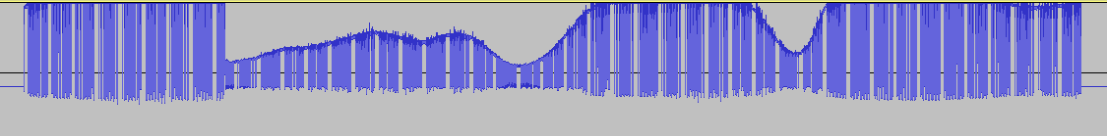

Zoom in to the signal, to look at the content further.

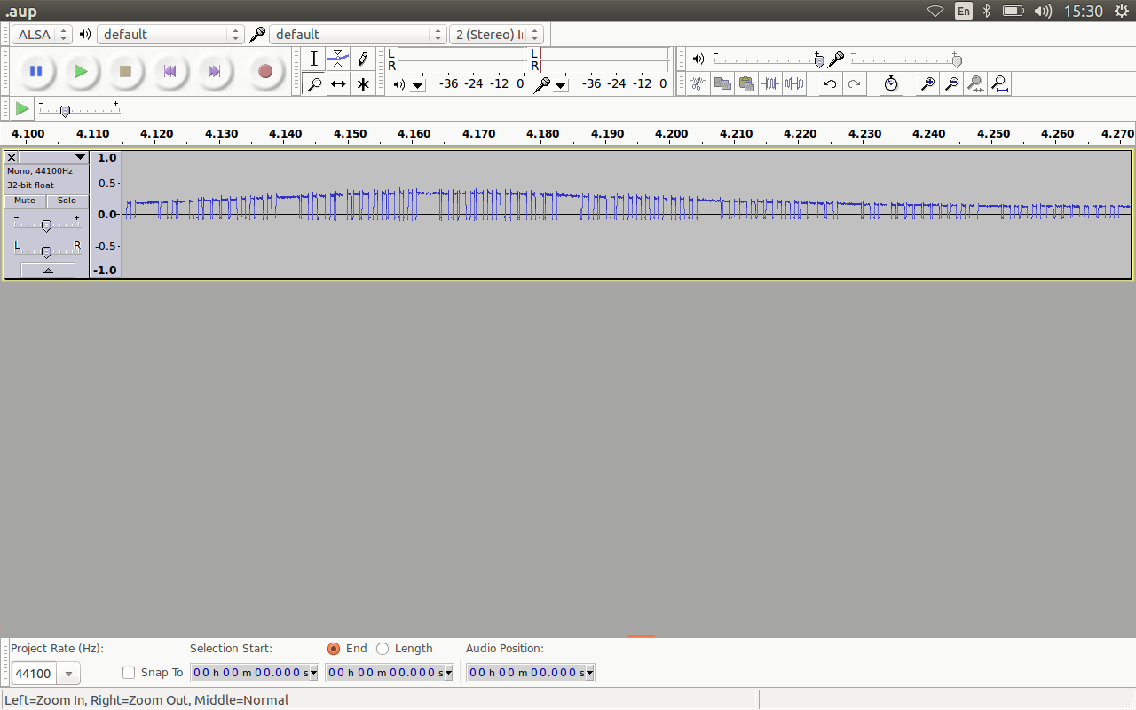
Look for discernible patterns that could be used to identify the signal (alarm type and the transmitting device type)

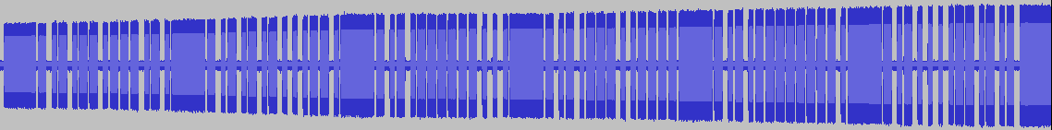
** Pic

Setup capture signal equipment - Gnuradio capture
Connect the HackRF to a laptop running the Gnuradio software.
Setup the capture flowgraph, if you don't know the frequency try capturing around 433.92 MHz
capture at a frequency offset, to the frequency you are setting (a DC spike is present at the set capture frequency).
Capture some signals and open them in Audacity, as previously described.

Processing part 1 - GNURadio flowgraph processing
Use a GNURadio flowgraph to process the signal initially.
Add components to the GNUradio flowgraph (FIR Filter, Add Constant, Low pass filter, Clock recovery mode Blocks) until you get a decimated, consistent, square or triangle wave with very few sample points in it.
The clock recovery mode Block output relies on getting the symbol rate (symbols per second) correct for the particular signal being transmitted. The symbol rate is different for each of the alarm panels that were looked at.
The clock recovery mode block output is fed into the Binary Slicer module, to produce the bits that you can work with.
The Binary sliced signal is then fed into Don Weber's grc_bit_converter.py file, to produce hex values, if a signal is present. These hex values are then processed further, depending on whether they indicate that a valid alarm signal is being transmitted.

Processing part 2 - ID alarm signals
Match preamble and synch part.
Each peripheral (Door reed or PIR) on the Yale, transmits a continuous signal, consisting of 6 parts that repeat throughout the entire signal. This is likely done for redundancy (ensuring the signal gets through), so that environmental factors don't negatively impact on the wireless alarm functionality.
One of the six parts is the same for all the reeds and PIRs, so the entire part could be used to identify that a Yale alarm peripheral is transmitting.

There are 2 parts that identify what the peripheral device type actually is (reed or PIR) and the remaining parts may be the serial number and/or the status of the peripheral.

** retest Reed open and close signal transmissions separately.

Replay ease is not the same as ease of Alarm signal fingerprinting.
Different methods of processing the signal had to be implemented in the processing code.

Parts that stay the same, which ID the signal as a Yale peripheral:

All Yale Reeds and PIRs have this part in common:
111 111 111 011 001 011 001 011 011 011 011 011 011 011 011 001 00

Yale Reed
111 111 111 011 001 011 001 011 001 011 001 001 011 011 011 001 00

111 111 111 011 001 011 001 011 011 011 011 001 011 011 011 011 00

Yale PIR
111 111 111 011 001 011 001 011 011 011 011 011 011 001 001 001 00
111 111 111 011 001 011 001 011 011 011 001 001 011 011 011 011 00

Yale Lock
111 111 111 011 001 011 001 011 011 011 011 011 011 011 011 011 00
111 111 111 011 001 011 001 001 011 011 011 001 011 011 011 011 00

Yale Unlock
111 111 111 011 001 011 001 011 011 011 011 011 011 011 001 001 00
111 111 111 011 001 011 001 001 011 011 011 011 001 001 011 001 00

Research Data section

1. Process captured peripheral .cap file through Yale gnuradio flowgraph
In the flowgraph change the following variables:
- select finput (input file)
- select add constant (initial constant of -0.25)
2. Import 3Yale_SampSym into audacity, 32 bit float, no endianess, Mono.
Adjust add constant offset, when you look at the 3Yale_SampSym signal after flowgraph processing. Adjust and record what you change it to, then add it into the signal name for 3Yale_Lock_2_point25_SampSym and 4Yale_Lock_2_point25_SampSym.

3. Edit process_files_Yale.py to add 4Yale_Lock_2_point25_SampSym in.
Use /YaleGnuRadioFiles/./process_files_Yale.py to produce the 4Yale_Lock_2_point25_SampSym.txt

4. Edit 4Yale_Lock_2_point25_SampSym.txt to remove starting \x00's. Leave first 3 \x00.
Edit last \x00 and leave last \x00's.

5. Edit process_yale_bits.py to include 4Yale_Lock_2_point25_SampSym.txt.
Run process_yale_bits.py, and record the frequency of certain 0 and f symbols.

6. If signal present, copy the 3Yale_Lock_2_point25_SampSym, 4Yale_Lock_2_point25_SampSym, 4Yale_Lock_2_point25_SampSym.txt and Capture_Yale_Lock_2.cap files into the Converted files to hex/Lock folder. Research data folder.

Replaying signals captured with hackrf_transfer
Capture at frequency (off centre) 435720000 MHz.
$ hackrf_transfer -a 1 -f 435720000 -r lock1_signal1_43572

Replay signal using Replay.sh script, loop 40 times

Appendix A - Results of Replay

Keyfobs - Record results
Loop 40 means it looped 40 times with no alarm/lick/unlock occurring.
Loop each signal 40 times, do this 6 times per signal.

lock1_signal1_43572
Loop 40

unlock1_signal1_43572

lock1_signal2_43572

unlock1_signal2_43572

lock1_signal3_43572

unlock1_signal3_43572

lock1_signal4_43572

unlock1_signal4_43572

Capture at 433920000 MHz
lock1_signal1_43392
Loop 40
Loop 40
Loop 40
Loop 40

unlock1_signal1_43392

lock1_signal2_43392

unlock1_signal2_43392

lock1_signal3_43392

unlock1_signal3_43392

lock1_signal4_43392

unlock1_signal4_43392

Lock_2 signal processed through -0.25 constant gnuradio flowgraph
0's f's
2 11
7 6
6 10
1 5
5 39
- 40
'' -
7
2
26

Lock_3 at -0.25 add constant offset
0's f's
2 11
6 6
7 10
1 5
5 39
- 40
'' -
3 8

Unlock_2 at -0.25 add constant offset
0's f's
2 10
7 5
6 11
1 6
8 39
- 40
'' -
9 36
3 7
1

Unlock_3 at -0.25 add constant offset
0's f's
7 11
2 6
6 10
1 5
'' 39
8 1
5 3
-
40

PIR1_3 at -0.2 add constant offset
0's f's
'' 11
2 5
7 10
8 6
3 48
1 50
4 1
5

PIR2_3 at -0.1 add constant offset
0's f's
2 11
7 10
3 6
8 5
'' 48
1
49
46
3
9

PIR1 at -0.5 add constant offset
0's f's
2 11
7 6
1 10
8 5
'' 48
3 49
46
47

PIR2 at -0.5 add constant offset
0's f's
2 11
7 6
8 10
3 5
1 48
- 49
9 46
47

PIR1_2 at -0.25 add constant offset
0's f's
2 11
7 6
8 10
3 5
1 48
49
46
47
9

Reed1_2_Open at -0.25 add constant offset
0's f's
3 10
2 5
9 11
8 6
7 42
10 4
41
3
9
-
51
1

Reed1_3_Open at -0.25 add constant offset
0's f's
3 10
9 5
2 11
8 42
'' 6
7 41
9
1
3
45
2
46

PIRs

Capture and replay at 433920000 Mhz
pir1_signal1_43392

pir2_signal1_43392

pir1_signal2_43392

pir2_signal2_43392

pir1_signal3_43392

pir2_signal3_43392

pir1_signal4_43392

pir2_signal4_43392

Capture and replay at 435720000 Mhz
pir1_signal1_43572

pir2_signal1_43572

pir1_signal2_43572

pir2_signal2_43572

pir1_signal3_43572

pir2_signal3_43572

pir1_signal4_43572

pir2_signal4_43572

Reeds
Capture and replay at 433920000 Mhz
reed1_signal1_43392

reed2_signal1_43392

reed1_signal2_43392

reed2_signal2_43392

reed1_signal3_43392

reed2_signal3_43392

reed1_signal4_43392

reed2_signal4_43392

Capture and replay at 435720000 Mhz
reed1_signal1_43572

reed2_signal1_43572

reed1_signal2_43572

reed2_signal2_43572

reed1_signal3_43572

reed2_signal3_43572

reed1_signal4_43572

reed2_signal4_43572

